**Experiment No - 04**

===============================================================================

**Author Name :** Vinni Fengade

**Roll No. :** 67

**Sem & Sec :** 7th Sem - CSE [B]

===============================================================================

**Aim :** Demonstrate the Virtual Network Private Security in the Public Cloud for

the Virtual Machine, Databases and Storage. Describe the step-by-step process, including subnet creation, route table configuration, and launching.

**Problem Statements:**

You are tasked with creating a new EC2 instance on Public Cloud (AWS) to host a web application. The application requires a Linux/Windows-based environment with 1 vCPUs, 1GB of RAM, and 30GB of storage. You also need to ensure that the instance is launched in a public subnet and has a public IP address.

**Task 1:**

The task of setting up a secure and isolated network environment using Amazon VPC in AWS.

**Task 2:**

To create a VPC with public and private subnets, configure appropriate routing, and launch instances in both subnets.

**===============================================================================**

Step1:login in your AWS academy learners lab and click on VPC

Step2:In the VPC Dashboard, choose Create VPC

Step3: Under VPC settings, choose VPC and more.Complete these fields as follows:

* Keep Auto-generated selected under Name tag auto-generation. Change project to ADS VPC.
* The IPv4 CIDR block should be 10.0.0.0/16.
* Keep No IPv6 CIDR block option selected.
* The Tenancy should remain Default.
* Select 2 for the Number of Availability Zones (AZs).
* Select 2 for the Number of public subnets. The number of private subnets can be changed to 0.
* Choose Customize subnet CIDR blocks to configure the public subnet IP address range. The public subnet CIDR blocks should be 10.0.0.0/20 and 10.0.16.0/20.
* Choose Create VPC. It takes several minutes for the VPC to be created.

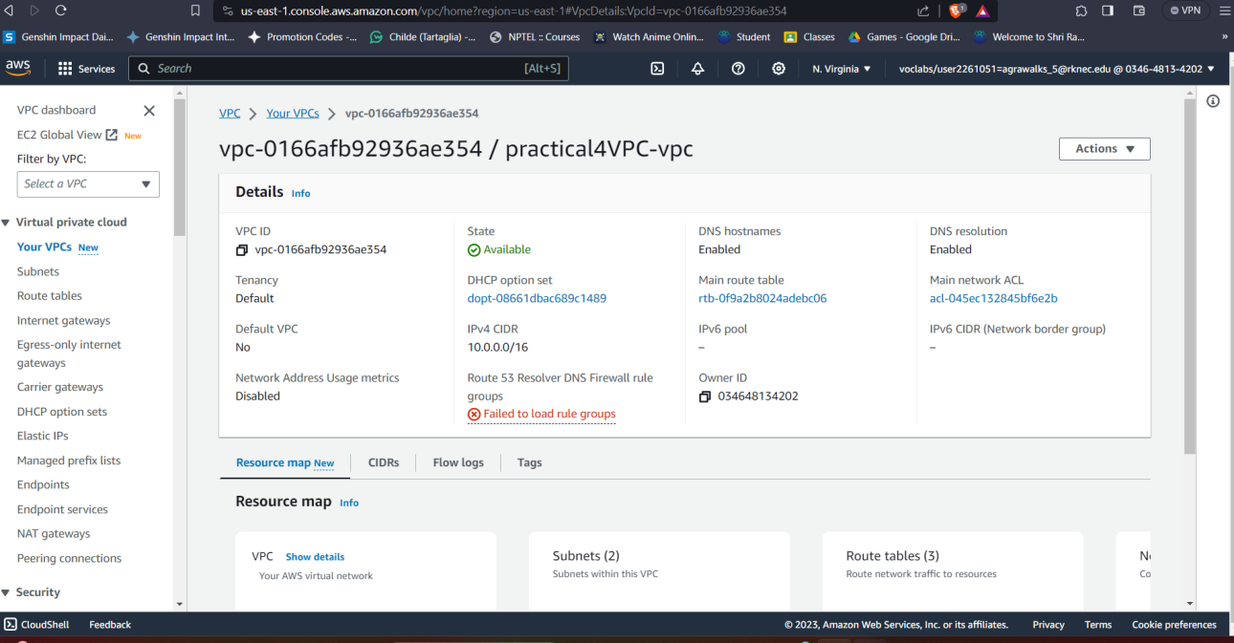

Part B: Create subnet in VPC

1. In the navigation pane, choose Subnets.
2. Choose Create subnet.
3. For VPC ID: Choose the VPC for the subnet.
4. (Optional) For Subnet name, enter a name for your subnet. Doing so creates a tag with a key of Name and the value that you specify.
5. For Availability Zone, you can choose a Zone for your subnet, or leave the default No Preference to let AWS choose one for you.
6. If the subnet should be an IPv6-only subnet, choose IPv6-only. This option is only available if the VPC has an associated IPv6 CIDR block. If you choose this option, you can't associate an IPv4 CIDR block with the subnet.
7. For IPv4 CIDR block, enter an IPv4 CIDR block for your subnet. For example, 10.0.1.0/24. If you chose IPv6-only, this option is unavailable.
8. For IPv6 CIDR block, choose Custom IPv6 CIDR and specify the hexadecimal pair value (for example, 00). This option is available only if the VPC has an associated IPv6 CIDR block.
9. Choose Create subnet.

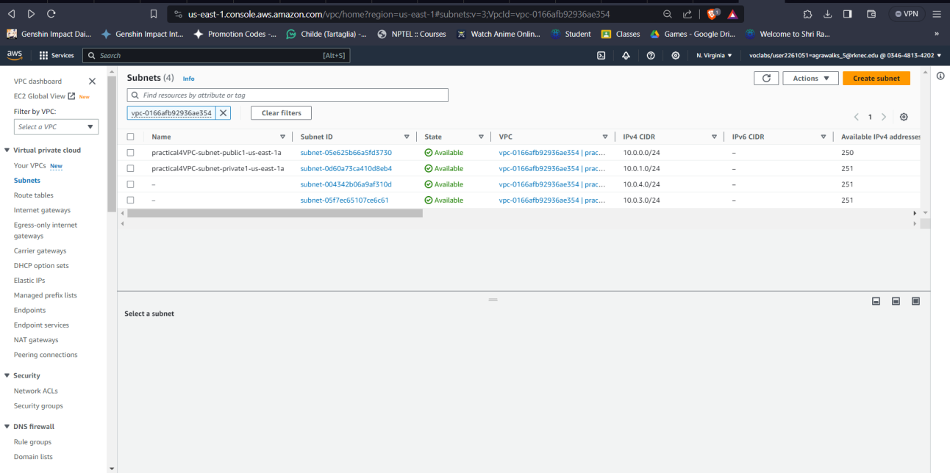

Part C: creation of subnet association

After creating subnets we need to associate the public ubnet to single routing table and private to another routing table

1. Click on subnet
2. Click on subnet association

1. Select route table association
2. In subnet association select the subnet you want to combine and click on save

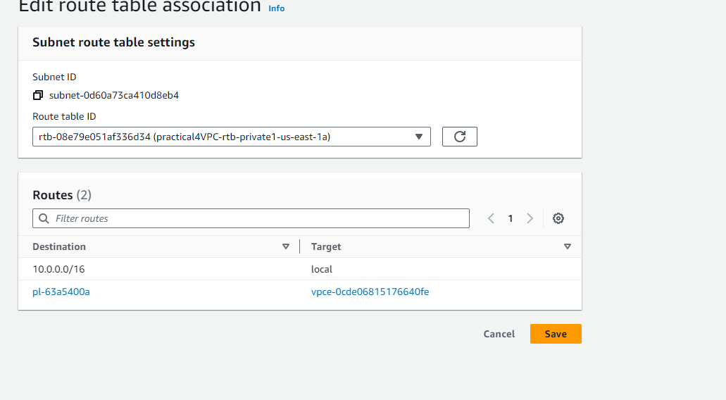

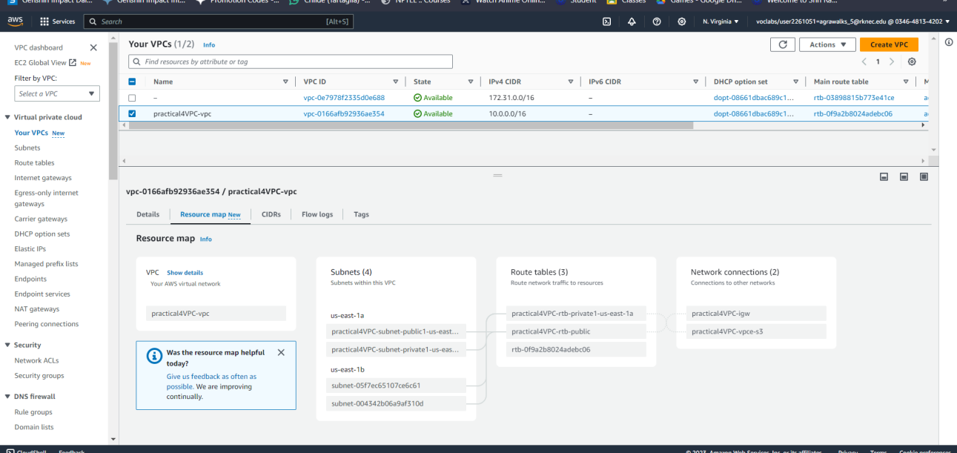

Prat 4 create a ec2 instance in VPC

1. Open dashboard and click on EC2 instance
2. Click on launch instance
3. While configuring the instance in network setting select the VPC as the VPC created in above instance and select public subnet
4. Remaining configurations can be default for creation of instance
5. Click on launch instance

